Nama : Andeas Devin Aprilio
Npm : 5520125035
Shift : 3 PBO
Tugas :
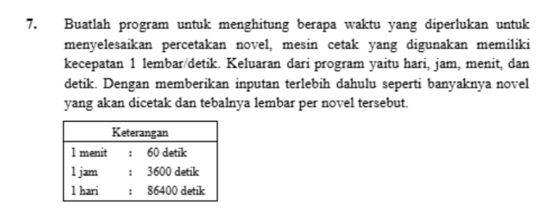
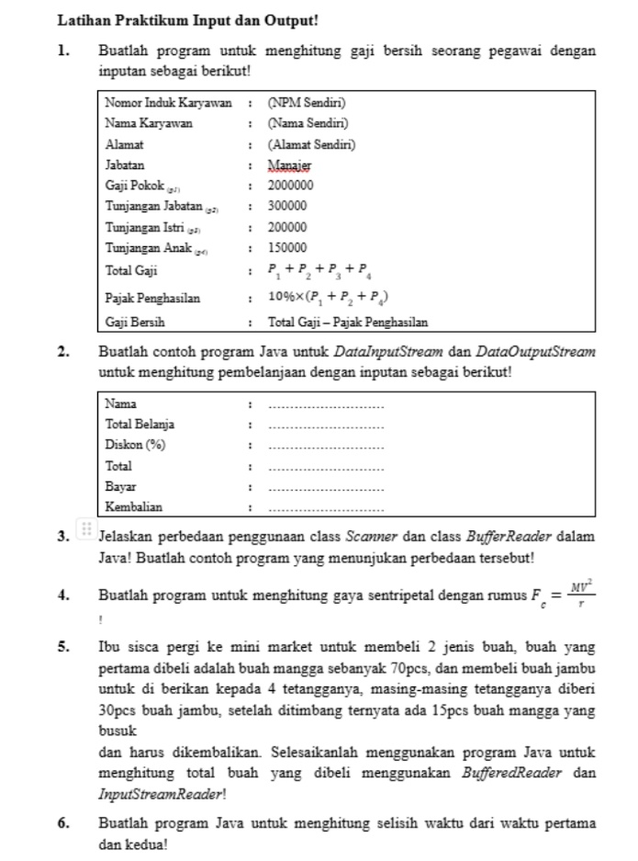

- Menghitung Gaji Bersih
- Input
package TugasJavaP3;

import java.util.Scanner;

public class GajiBersih {
public static void main(String[] args) {
Scanner in = new Scanner(System.in);
System.out.print("Nomor Induk Karyawan : "); String npm = in.nextLine();
System.out.print("Nama Karyawan : "); String nama = in.nextLine();
System.out.print("Alamat : "); String alamat = in.nextLine();

double pokok = 2000000, jabatan = 300000, istri = 200000, anak = 150000;
double total = pokok + jabatan + istri + anak;
double pajak = 0.10 * (pokok + jabatan + istri);

System.out.println("\nNomor Induk Karyawan : " + npm);
System.out.println("Nama Karyawan : " + nama);
System.out.println("Alamat : " + alamat);
System.out.println("Jabatan : Manajer");
System.out.println("Gsji pokok : 2000000");
System.out.println("Tunjangan Jabatan : 300000");
System.out.println("Tunjangan Istri : 200000");
System.out.println("Tunjangan Anak : 150000");

System.out.println("Total Gaji : Rp" + total);
System.out.println("Pajak Penghasilan : Rp" + pajak);
System.out.println("Gaji Bersih : Rp" + (total - pajak));
}
}

- Output
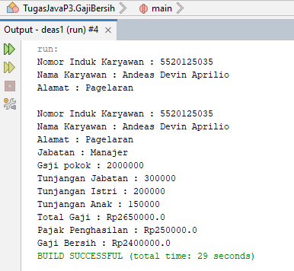

- Menghitung Pembelanjaan
- Input
package TugasJavaP3;

import java.io.*;

public class MenghitungPembelanjaan {
public static void main(String[] args) throws IOException {
DataInputStream in = new DataInputStream(System.in);
PrintStream out = System.out;

out.print("Nama : ");
out.flush();
String nama = in.readLine();

out.print("Total belanja : ");
out.flush();
double belanja = Double.parseDouble(in.readLine());

out.print("Diskon (%) : ");
out.flush();
double diskon = Double.parseDouble(in.readLine());

out.print("Uang bayar : ");
out.flush();
double bayar = Double.parseDouble(in.readLine());

double total = belanja - (belanja * diskon / 100);
double kembali = bayar - total;

out.println("\nHASIL BELANJA");
out.println("Nama: " + nama);
out.println("Total setelah diskon: Rp." + total);
out.println("Bayar: Rp." + bayar);
out.println("Kembalian: Rp." + kembali);
}
}

- Output
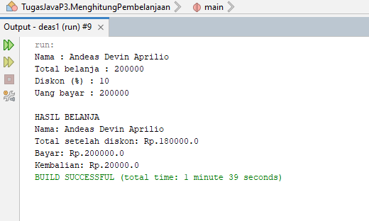

- Perbedaan Scanner dan BufferedReader

1. Scanner
Lebih mudah digunakan untuk membaca input.
Bisa membaca teks, angka bulat (int), dan angka desimal (double) secara langsung.
Contohnya menggunakan nextInt() untuk membaca angka.
2. BufferedReader
Digunakan untuk membaca input dalam bentuk teks per baris.
Kalau ingin membaca angka, teksnya harus diubah dulu menggunakan Integer.parseInt().
Contohnya menggunakan readLine() untuk membaca satu baris input.

- Input Scanner
package TugasJavaP3;

import java.util.Scanner;

public class Scanner1 {
public static void main(String[] args) {
Scanner in = new Scanner(System.in);
System.out.print("Masukkan umur : ");
int umur = in.nextInt();
System.out.println("Umur saya " + umur + " tahun");
}
}

- Output
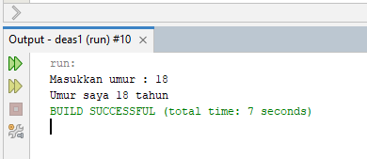

- Input BufferReader
package TugasJavaP3;

import java.io.*;

public class BufferReader1 {
public static void main(String[] args) throws IOException {
BufferedReader in = new BufferedReader(new InputStreamReader(System.in));
System.out.print("Masukkan umur : ");
int umur = Integer.parseInt(in.readLine());
System.out.println("Umur saya " + umur + " tahun");
}
}

- Output
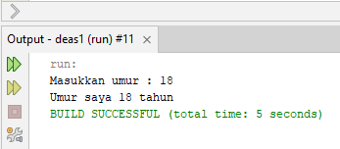

- Menghitung Gaya Sentripetal
- Input
package TugasJavaP3;

import java.util.Scanner;
public class Sentripetal {
public static void main(String[] args) {
Scanner in = new Scanner(System.in);
System.out.print("Massa (kg) : "); double m = in.nextDouble();
System.out.print("Kecepatan (m/s) : "); double v = in.nextDouble();
System.out.print("Jari-jari (m) : "); double r = in.nextDouble();
if (r <= 0) { System.out.println("Jari-jari harus lebih dari 0"); return; }
double f = m * v * v / r;
System.out.println("Gaya sentripetal = " + f + " N");
}
}

- Output
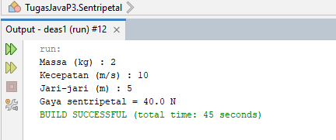

- Tot Buah Menggunakan InputStreamRaider Dan BufferRaider
- Input
package TugasJavaP3;

import java.io.*;

public class TotBuahBufferRaider {
public static void main(String[] args) throws IOException {
BufferedReader in = new BufferedReader(new InputStreamReader(System.in));
int mangga = 70, busuk = 15, tetangga = 4, jambu = 30;
int totalBeli = mangga + (tetangga * jambu);
int totalBaik = (mangga - busuk) + (tetangga * jambu);
System.out.println("Total buah dibeli : " + totalBeli);
System.out.println("Mangga busuk dikembalikan : " + busuk);
System.out.println("Total buah setelah dikembalikan : " + totalBaik);
}
}

- Output
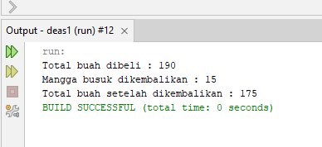

- Menghitung Selisih Waktu
- Input
package TugasJavaP3;

import java.util.Scanner;
public class SelisihWaktu {
public static void main(String[] args) {
Scanner in = new Scanner(System.in);
System.out.print("Jam pertama : "); int j1 = in.nextInt();
System.out.print("Menit pertama : "); int m1 = in.nextInt();
System.out.print("Detik pertama : "); int d1 = in.nextInt();
System.out.print("Jam kedua : "); int j2 = in.nextInt();
System.out.print("Menit kedua : "); int m2 = in.nextInt();
System.out.print("Detik kedua : "); int d2 = in.nextInt();
int t1 = j1 * 3600 + m1 * 60 + d1;
int t2 = j2 * 3600 + m2 * 60 + d2;
int selisih = Math.abs(t1 - t2);
System.out.println("Selisih : " + selisih / 3600 + " jam, " + (selisih % 3600) / 60 + " menit, " + selisih % 60 + " detik");
}
}

- Output
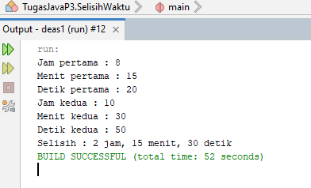

- Menghitung Berapa Waktu
- Input
package TugasJavaP3;

import java.util.Scanner;

public class MesinCetakNovel {
public static void main(String[] args) {
Scanner in = new Scanner(System.in);
System.out.print("Jumlah novel : "); int novel = in.nextInt();
System.out.print("Jumlah lembar per novel : "); int lembar = in.nextInt();
int total = novel * lembar;
System.out.println("Total lembar : " + total);
System.out.println("Waktu : " + total / 86400 + " hari, " + (total % 86400) / 3600 + " jam, " + (total % 3600) / 60 + " menit, " + total % 60 + " detik");
}
}

- Output
